Nano Zeolite Cement Modification for Soil Stabilisation

The Nano crystallization process developed by PowerCem Technologies is created by applying a mixture of soil of any kind (organic and inorganic), synthetic zeolites and cement.
The porous and intricate nature of zeolite structures allows for the total hydration of the mixture, uniquely this allows cement to be hydrated to 100%, reducing cement requirements by up to 30%. There is also a substantial increase in the generation of calcium crystals that provide increased resistance and mechanical properties in stabilization.
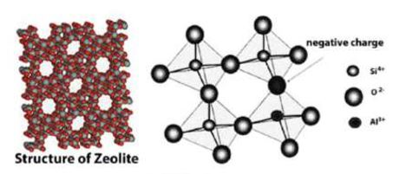
Zeolites are aluminosilicate minerals of porous nature, in their natural state they have a three-dimensional panel structure, which stands out for its ability to hydrate and dehydrate. These minerals are normally found in both sedimentary and volcanic and metamorphic rocks. Based on the years of research by PowerCem BV in the Netherlands into the structure of zeolites in their natural state, more than 150 variations of synthetic zeolites were created from nanotechnology processes which are now used to fulfil specific functions in the three PowerCem products.

The specially designed synthetic zeolites and other patented components allow stabilisation of any type of soil and provide unique properties that allow a better interaction between soil, cement, and zeolites to improve their characteristics.
The Nano stabilisation process created by PowerCem can take full advantage of the fine particles found in waste stream ashes; PFA, GGBS and IBA. Recent research by several UK Universities has shown that these ashes can be used to directly to replace cement in mixes by up to 70%, as shown in the following chart.

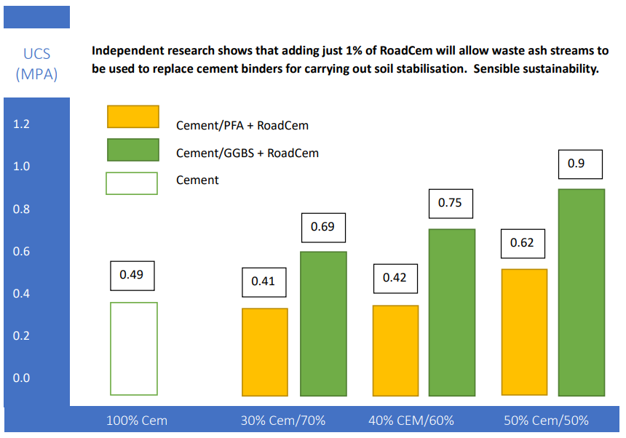
The above chart shows early seven-day results with a cohesive clay and are based on a mix design of 8% cementitious binder by volume of soil (approximately 4% by weight).

Whilst these results show the efficacy of replacing high carbon cements with waste ash streams. The true benefit of the nano process is increasing density and filing voids by stimulating crystal growth, which allows our partners Rodgers Leask Consulting Engineers to provide contractors with accurate bound soil element designs that are virtually crack free and impermeable.
Using Bisar strain analysis software high dynamic strength models can be tailored to meet client’s foundation base loading requirements with a good margin of safety for most ground conditions and soil types.
Nano soil stabilisation increases dynamic stiffness, which can:
- Increase permeability
- Reduce the risk of settlement
- Increase stability
- Improve shear strength
- Reduce the potential for swelling and shrinkage characteristics
Nano soil stabilisation acts as a water and weather barrier when used for pavement base, embankments and foundations for infrastructure elements creating and maintaining a strength that will remain a constant for many years.

